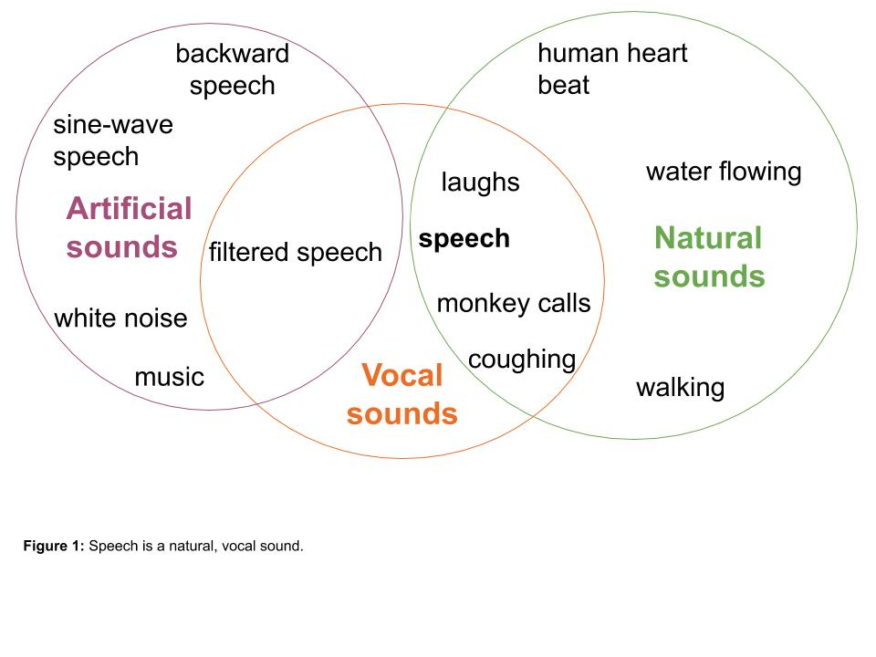

**Figure 1:** Speech is a natural, vocal sound.

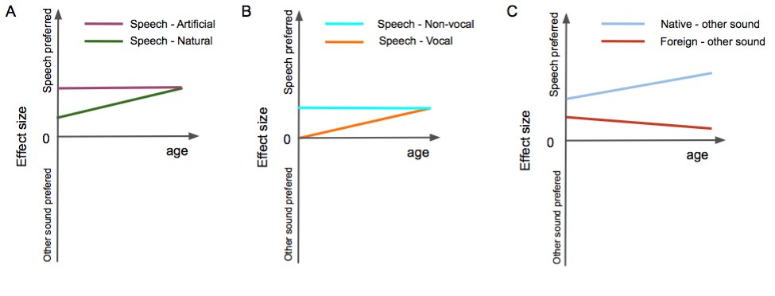

**Figure 2**: Possible pattern of speech preference (effect size, preference for speech is up) across age. A: Speech contrasted to natural (green) or artificial (purple) sounds. B: Speech contrasted to vocal (orange) or non-vocal (cyan) sounds. C: speech in a foreign language (red); speech in the native language (blue).



**Figure 3:** PRISMA flowchart summarizing the litterature review and inclusion process.

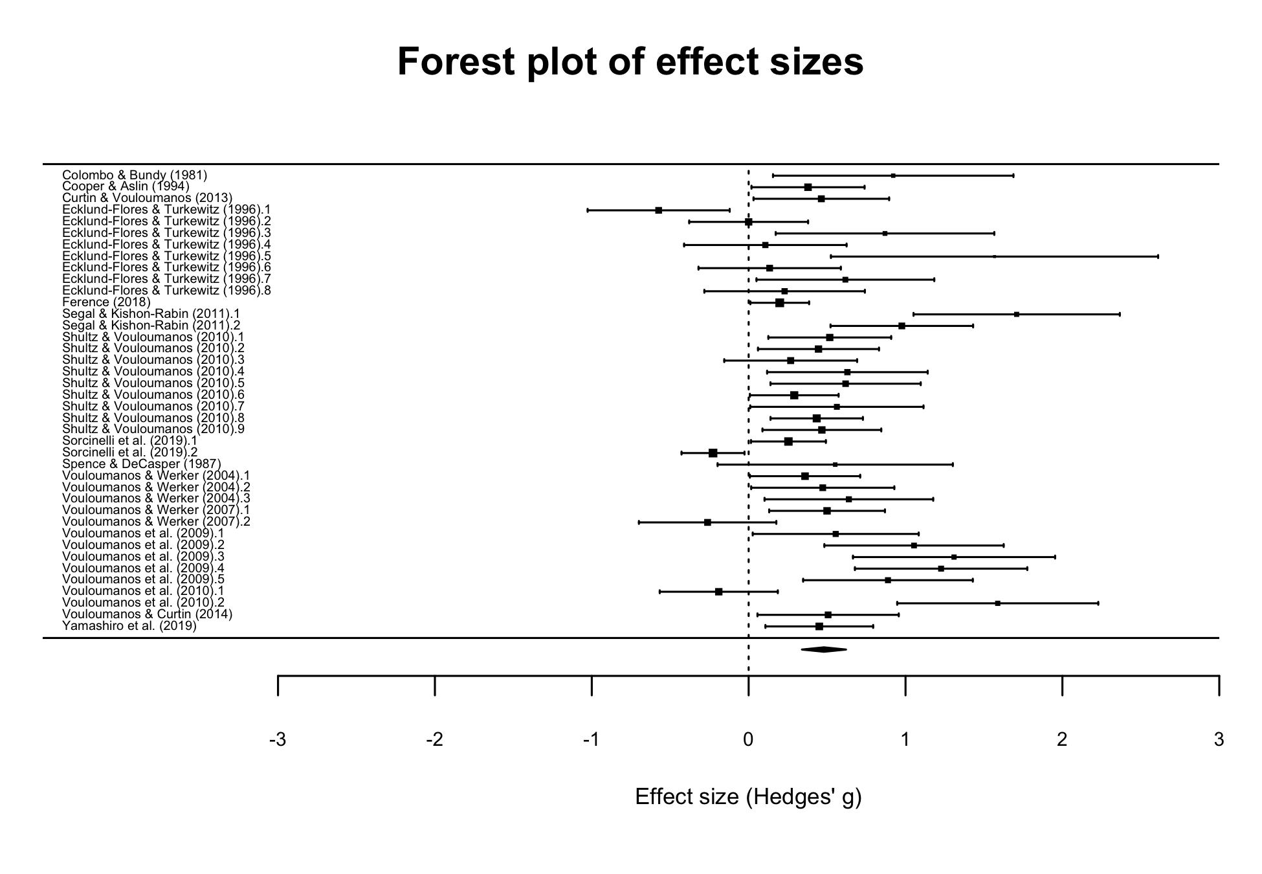

**Figure 4:** Effect sizes of individual studies with corresponding confidence intervals (upper part), and summary effect size across the literature (diamond, lower part). The size of the square is proportional to the weight of each effect size in the meta-analytic model.

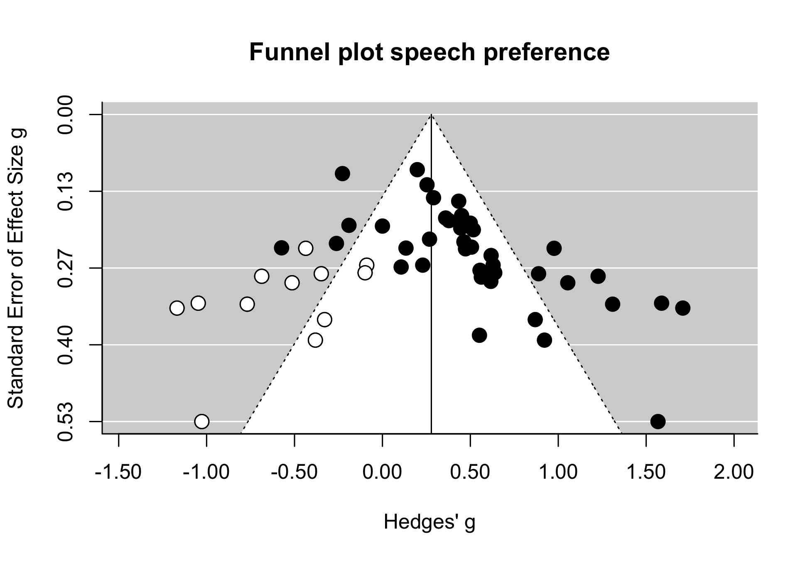

**Figure 5:** Funnel plot of study precision as a function of effect sizes. Black dots: effect sizes observed in the literature. White dots: missing effect sizes to symmetrize the plot (indicative of a publication bias). The vertical line corresponds to the estimated effect size after adding the missing studies.